DESIGN DOCUMENT

IntroductionSummaryObstructions or debris in fan and air passage system of industrial duct fans leads to improper flow of air in to the building leading to discomfort and eventually suffocation. Condition monitoring of such duct fans is an increasing concern as construction of masonry structures is taking place.

Background Existing scenario:

* Although HVAC airflow problems have many causes, most of them are being mitigated by HVAC preventative maintenance.
* Since many a times the duct work and fan lights get clogged that calls for maintenance leading to downtime.
* Preventative maintenance is performed while the equipment is performing normal, this leads to breakdowns and additional cost.
* The clogging of duct fans is a function of runtime and level of dust being accumulated. This is not being considered while carrying of maintenance activities.
* The system does not proactively alerts the operation personal based on the performance of duct fans.
* There is no framework to continuously monitor the minute performance of duct fan from remote location.

Proposed Solution:

A predictive maintenance algorithm which alerts the operations personal on the condition of duct fan is proposed. The algorithm differentiates between obstruction to airflow and dust deposits on the impeller blades. Besides this, the status (running or stalled) of the duct fan is continuously logged to cloud for remote monitoring.

Definitions, Acronyms, and AbbreviationsDefinition of terms that will help readers understand the documents, or acronyms common in your project areaDesign OverviewRequirements

* There is a framework to continuously monitor the minute performance of duct fan from remote location.
* Dust accumulation on fan blade.
* Obstruction of airflow through fan.
* Fan motor status (ON/OFF).
* Loose connection in ducts/fan structure.
* Any anomaly behavior.

Documentation

* https://towardsdatascience.com/introduction-to-machine-learning-db7c668822c4.

Minimum Viable Product

A detailed description of the deliverable for this project, this is the minimal functionality required for the project to be considered successful and should not include stretch goals or future work.Stretch goals

Stretch goals include functionality beyond the scope of the minimum viable product that should be include in the project should time and budget permit. Unlike future work, stretch goals would be smaller tasks for features in support of the minimum viable product.Future work

* To improve the accuracy of the fan using different machine learning algorithms.

Architectural Diagrams 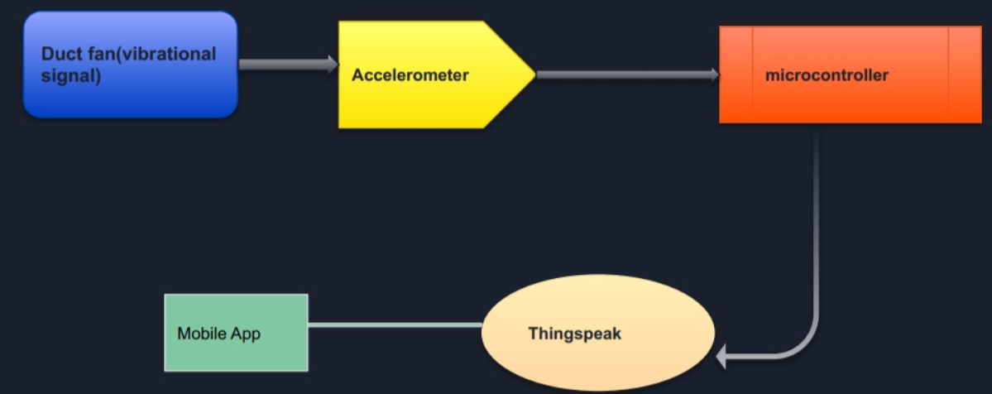

System Diagrams 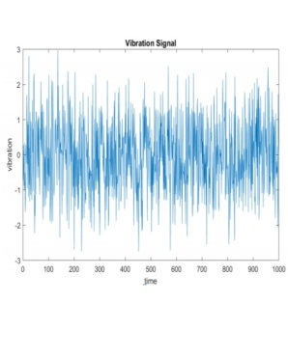 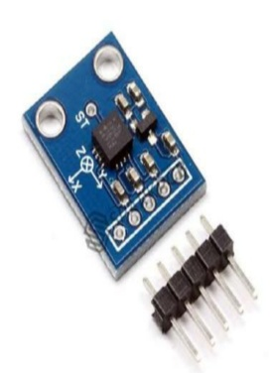 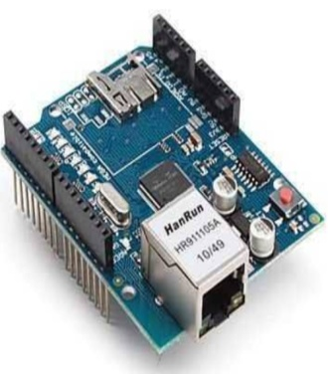 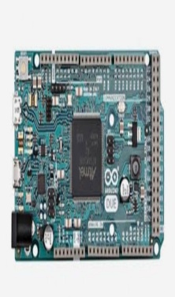 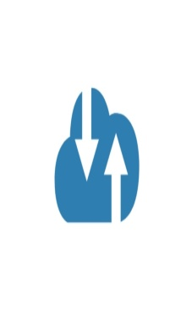

Application Programming InterfaceFor services, libraries, and command line interfaces that present an interface which can be wrappedRecommendationsUsing a versioned endpoint simplifies the process of making future backwards incompatible API changes;User InterfaceFor frontends, a mockup can be attached to illustrate the user interface. Command line interfaces may include a list of subcommands and their options.Data Models and StorageFor projects requiring messages queue such as Kafka, MYSQL, etc.KafkaHow many partitions are needed for this topic?How many days of retention will be needed?What will the partitioning key become?How much data will be written to the topic during peak hours?What type of Kafka cluster will be needed? (E.g. aggregate, queuing, tracking, metrics, logging) MYSQLWhat does the table schema look like and how are they all tied together (provide a UML)?What sort of updates will be made to the tables?How will users make queries to the tables? (e.g. Complex joins, pre-filtering, single record gets) What the strategy for indexing?Service OperabilityKey Performance IndicatorsKey performance indicators (KPI), describe how a service should be monitored and how its performance can be gauged. This would typically include an overview of the types of metrics an application will need to emit, call time, error rate, etc.Service Level ObjectivesService level objectives (SLOs), set targets for various KPI through alerts via email or SMS, these targets may provide early indicators of approaching a capacity limit, changes in load patterns through various phases of an application, changes in duration of offline processing, etc. Project OverviewCommunication and TrackingCHANNELS:

* Direct Marketing
* Wholesale

PROMOTION:

* Business Networks
* Promotional Events
* Social Media
* Creating Web Pages
* Advertisements in local Channels.

RisksThe position of the all the duct fans, rpm of all the fans in the particular usage sector should of fixed/same, then only integration of all the duct fans is possible.

Milestones The pending work is only improving the accuracy of the duct fan, it will be completed on June 20, 2019.

Project PhasesFor projects that are better tracked and reported on in multiple phases because of extended timelines, external dependencies, etcCost

We are working on this project since 1 month.

The total cost for each product is 4000/-.

Frequently Asked Question

References

* https://aristair.com/blog/top-10-causes-of-hvac-airflow-problems/
* <https://www.emaint.com/preventive-vs-predictive-maintenance/>
* [www.amca.org/whitepapers](http://www.amca.org/whitepapers)
* Application Notes: Vibration Diagnostics for industrial Electric Motor Drives, Bruel & Kjaer.

AddendumAdditional diagrams or details that do not particularly belong in the body of the design doc. This could also be a place to describe additional examples that would otherwise bloat the introduction section. More specifics on APIs could also be placed here for engineers to reference.